GIT OVERVIEW

GIT:
Git is a distributed revision control and source code management system with an emphasis on speed. Git was initially designed and developed by Linus Torvalds for Linux kernel development. Git is a free software distributed under the terms of the GNU General Public License version 2. This tutorial explains how to use Git for project version control in a distributed environment while working on web-based and non web-based applications development.

GIT Basic Concepts:
Version Control System
Version Control System (VCS) is a software that helps software developers to work together and maintain a complete history of their work.
Listed below are the functions of a VCS −
- Allows developers to work simultaneously.
- Does not allow overwriting each other’s changes.
- Maintains a history of every version.
Following are the types of VCS −
- Centralized version control system (CVCS).
- Distributed/Decentralized version control system (DVCS).
In this chapter, we will concentrate only on distributed version control system and especially on Git. Git falls under distributed version control system.

Distributed Version Control System
Centralized version control system (CVCS) uses a central server to store all files and enables team collaboration. But the major drawback of CVCS is its single point of failure, i.e., failure of the central server. Unfortunately, if the central server goes down for an hour, then during that hour, no one can collaborate at all. And even in a worst case, if the disk of the central server gets corrupted and proper backup has not been taken, then you will lose the entire history of the project. Here, distributed version control system (DVCS) comes into picture.
DVCS clients not only check out the latest snapshot of the directory but they also fully mirror the repository. If the server goes down, then the repository from any client can be copied back to the server to restore it. Every checkout is a full backup of the repository. Git does not rely on the central server and that is why you can perform many operations when you are offline. You can commit changes, create branches, view logs, and perform other operations when you are offline. You require network connection only to publish your changes and take the latest changes.

Advantages of Git

Free and open source
Git is released under GPL’s open source license. It is available freely over the internet. You can use Git to manage property projects without paying a single penny. As it is an open source, you can download its source code and also perform changes according to your requirements.

Fast and small
As most of the operations are performed locally, it gives a huge benefit in terms of speed. Git does not rely on the central server; that is why, there is no need to interact with the remote server for every operation. The core part of Git is written in C, which avoids runtime overheads associated with other high-level languages. Though Git mirrors entire repository, the size of the data on the client side is small. This illustrates the efficiency of Git at compressing and storing data on the client side.

Implicit backup
The chances of losing data are very rare when there are multiple copies of it. Data present on any client side mirrors the repository, hence it can be used in the event of a crash or disk corruption.

Security
Git uses a common cryptographic hash function called secure hash function (SHA1), to name and identify objects within its database. Every file and commit is check-summed and retrieved by its checksum at the time of checkout. It implies that, it is impossible to change file, date, and commit message and any other data from the Git database without knowing Git.

No need of powerful hardware
In case of CVCS, the central server needs to be powerful enough to serve requests of the entire team. For smaller teams, it is not an issue, but as the team size grows, the hardware limitations of the server can be a performance bottleneck. In case of DVCS, developers don’t interact with the server unless they need to push or pull changes. All the heavy lifting happens on the client side, so the server hardware can be very simple indeed.

Easier branching
CVCS uses cheap copy mechanism, If we create a new branch, it will copy all the codes to the new branch, so it is time-consuming and not efficient. Also, deletion and merging of branches in CVCS is complicated and time-consuming. But branch management with Git is very simple. It takes only a few seconds to create, delete, and merge branches.

Basic workflow of Git.
Step 1 − You modify a file from the working directory.
Step 2 − You add these files to the staging area.
Step 3 − You perform commit operation that moves the files from the staging area. After push operation, it stores the changes permanently to the Git repository.

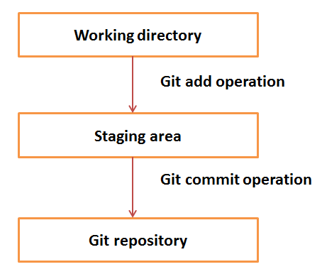

Installation of Git Client
If you are using Debian base GNU/Linux distribution, then apt-get command will do the needful.
sudo apt-get install git-core

And if you are using RPM based GNU/Linux distribution, then use yum command as given.
yum -y install git-core

Git Lifecycle:
In this chapter, we will discuss the life cycle of Git. In later chapters, we will cover the Git commands for each operation.
General workflow is as follows −
- You clone the Git repository as a working copy.
- You modify the working copy by adding/editing files.
- If necessary, you also update the working copy by taking other developer's changes.
- You review the changes before commit.
- You commit changes. If everything is fine, then you push the changes to the repository.
- After committing, if you realize something is wrong, then you correct the last commit and push the changes to the repository.
Shown below is the pictorial representation of the work-flow.
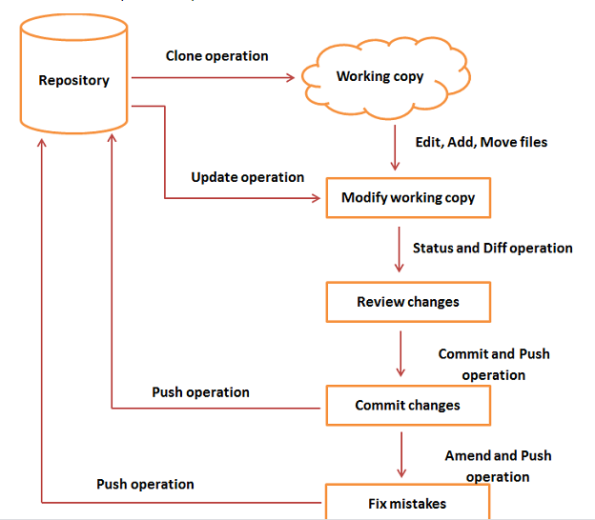

Git clone:
Clone operation creates the instance of the repository. Clone operation not only checks out the working copy, but it also mirrors the complete repository. Users can perform many operations with this local repository. The only time networking gets involved is when the repository instances are being synchronized.

Perform Changes:
Git is showing a question mark before file names. Obviously, these files are not a part of Git, and that is why Git does not know what to do with these files. That is why, Git is showing a question mark before file names.
Using commands git add, git status and git commit
Review changes:
Using git log, git show <commit id>, git diff
Commit changes:
Using git status –s, git add, and git commit
Push Operation:
Push operation copies changes from a local repository instance to a remote one. This is used to store the changes permanently into the Git repository. This is same as the commit operation in Subversion.
Using command:- git push origin <origin name>
Pull Operation:
Pull operation copies the changes from a remote repository instance to a local one. The pull operation is used for synchronization between two repository instances. This is same as the update operation in Subversion.
Using command:- git pull
Stash Operation:-
Suppose you are implementing a new feature for your product. Your code is in progress and suddenly a customer escalation comes. Because of this, you have to keep aside your new feature work for a few hours. You cannot commit your partial code and also cannot throw away your changes. So you need some temporary space, where you can store your partial changes and later on commit it.
In Git, the stash operation takes your modified tracked files, stages changes, and saves them on a stack of unfinished changes that you can reapply at any time.
Using commands:- git stash, git stash list

Move Operation:-
The move operation moves a directory or a file from one location to another.
Using command:- git mv <directory/file> <new location>
Rename Operation:-
Rename operation is used for change file name.
Using command:- git mv <old file name> <new file name>
Delete Operation:-
Used for to remove file from repository
Using command:- git rm <filename>
Tag Operation:
Tag assigns a meaningful name with a specific version in the repository. Tags are very similar to branches, but the difference is that tags are immutable. It means, tag is a branch, which nobody intends to modify. Once a tag is created for a particular commit, even if you create a new commit, it will not be updated. Usually, developers create tags for product releases.
Using commands:- git tag, git show <tag name>,
git tag –d <tag name> -→ For delete tag
Managing Branches:-
Branches are used to create another line of development. By default, Git has a master branch, which is same as trunk in Subversion. Usually, a branch is created to work on a new feature. Once the feature is completed, it is merged back with the master branch and we delete the branch. Every branch is referenced by HEAD, which points to the latest commit in the branch. Whenever you make a commit, HEAD is updated with the latest commit.
Using commands:- git branch, git branch <new branch name>, git checkout <branch name>
Git checkout –b <new branch name>
Git branch –D <branch name> -→ For delete branch

Sample Outputs:-
